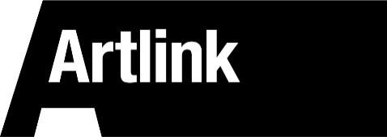

BOARD MEMBER APPLICATION FORM

Print clearly in black or blue ink. Answer all questions. Sign and date the form. Artlink encourages applications from disabled people. Please tell us any reasonable adjustments we can make to help you with this application form.

- PERSONAL INFORMATION:

First Name: Last Name:

Street Address:

Post Code:

Phone Number:

- DETAILS:

- Please read the About Us and About You document and tell us why you meet the criteria.

- Tell us why you are interested in the work of Artlink?

- How did you hear about this opportunity?

- Is there anything else you would like to add?

- Referees - please give us the names and contact details of two referees.

- Name: 2. Name:

Contact: Contact:

Please return the form by email to: info@artlinkedinburgh.co.uk or print and post to Artlink, Board Member Application, 13a Spittal Street, Edinburgh, EH3 9DY

This application form can be provided in whatever format is needed.

