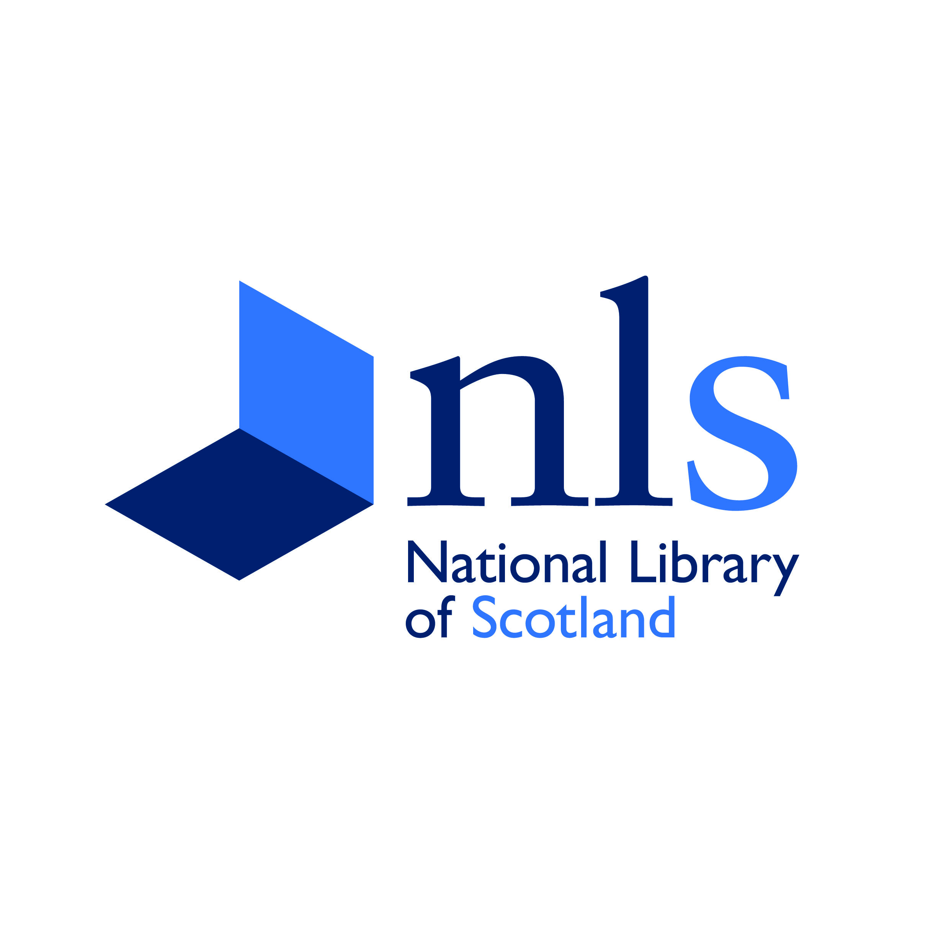
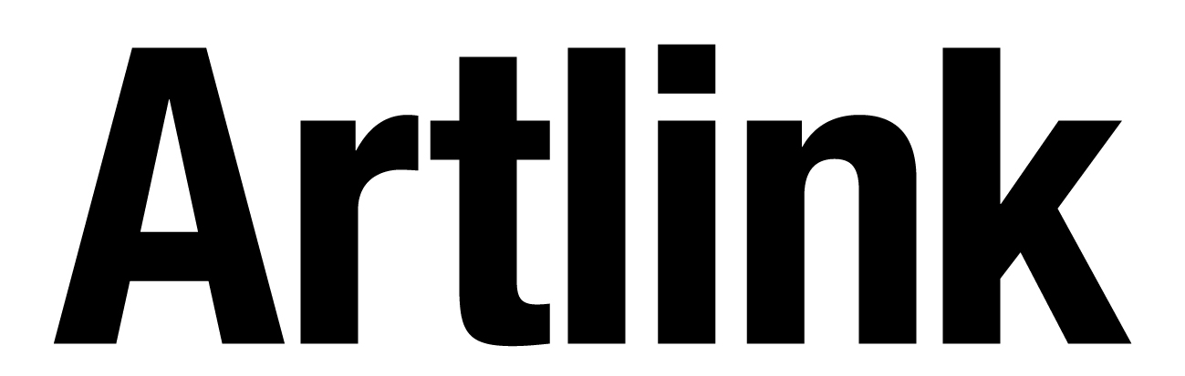

Artlink and National Library of Scotland
Investigative Placement
Call for artist proposals
Deadline 6 December

Artlink and the National Library of Scotland are seeking an artist for an Investigative Placement exploring unexpected and diverse experiences of the library’s spaces. The placement will playfully explore descriptive language to create a response that acknowledges and offers diverse experiences of the library with sighted, partially sighted and blind participants. The Investigative Placement will take place between January and April 2014.

Background
Artlink is an arts and disability organisation based in Edinburgh. This Investigative Placement is part of a series of projects exploring the creative potential of access tools, such as verbal description, through collaboration between artists, venues and audiences. Artlink’s work and approach promotes diversity by drawing on lived experiences to inform arts responses which are relevant and enduring.

The National Library of Scotland (NLS) is Scotland’s largest research library housing millions of books, manuscripts and maps. It is the world’s leading centre for the study of Scotland and the Scots, and also holds material relating to global history and culture. As a legal deposit library, NLS has the right to claim a copy of every book published in the UK, and the collections cover a vast range of subjects, from literature and history to science, technology, and politics. NLS also holds one of the ten largest map collections in the world. The opportunity will be based in the main Library building on George IV Bridge where the reading rooms, curators, and conservators are located. There is also an exhibition gallery, events space, bookshop, and café.

Artlink and the National Library of Scotland have been working in partnership for 7 years to improve access to the library’s public programme for visually impaired, hard of hearing and Deaf visitors. The idea for this placement developed from a tour of the building for visually impaired visitors and the library has a regular programme of descriptive events in association with Artlink. The library is seeking to further engage staff at all levels and in all departments in their equalities work.

The Project
The Investigative Placement gives time for an artist to explore the library building on George IV Bridge from a range of perspectives and develop a descriptive event for sighted and partially sighted audiences. The artist will involve members of library staff and visually impaired participants to understand the various ways the library is used and experienced.
This placement will explore descriptive language to create a response that acknowledges and offers diverse experiences of a space. Following a series of exploratory events with staff and visually impaired participants, the Investigative Placement will result in a final sharing event for sighted and partially sighted audiences.
Artlink’s approach across several projects is to take often functional access services, such as verbal description, as starting points for creative exploration. By finding crossovers between artists’ and audiences’ interests, this becomes an opportunity to explore descriptive language. The involvement of visually impaired individuals is central to the work at all stages. For more information on related work, see Artlink’s project blog: www.investigatecreate.wordpress.com
Aims (from Artlink’s Investigate Create programme)
- Provide new opportunities for individuals with visual impairments, hearing loss and sign language users to engage with the arts.
- Develop creative approaches to access through collaboration between artists, venues and audiences.
- Present diverse experiences of participation in the arts.
- Bring people together through shared experiences to spark new imaginings around accessibility in the arts.

Project outcomes
- Explore the diverse ways the National Library of Scotland is used and experienced, working with members of staff and individuals with sight loss.
- Create a series of exploratory events for those involved in the project.
- Develop a public performance around the building drawing on a range of perspectives and experiences.
- Audio and visual documentation of the process and final event.

Artist’s Approach
For this placement we are seeking an artist with the following experiences and interests:

- Experienced as both a writer and performer, with a particular interest in descriptive language.
- Interested in exploring spaces in unexpected ways and developing narrative responses.
- Whose practice is informed by the particular experiences of the people involved with a project.
- Enjoyment of collaborative processes which shape understandings and surprising responses.

Practical Information
The artist will be based within the Library’s George IV Bridge or Lawnmarket building. Desk space and access to a computer will be provided throughout the residency.
The artist fee is £2,400 (approximately 15 days).
The Investigative Placement will take place between January and April 2014.
The project is jointly managed by Susan Humble, Audience Development Officer, Artlink and Beverley Casebow, Education and Outreach Officer, National Library of Scotland. Artlink is the main contact for the artist and project.
We welcome applications from everyone with the relevant experience, if you have any questions, please contact Susan at Artlink, contact details below.

Application
To be considered for this opportunity, please send your CV with a statement (1,000 words maximum) detailing previous experience, your approach to the brief and ways you would involve participants with visual impairments in the process. You may also include documentation of previous work of particular relevance.

Deadline for application Friday 6 December 2013
You may be invited to discuss your proposal further, date for interviews will be Tuesday 17December.
The successful artist will be asked to complete a Disclosure Scotland check.

Contact Susan Humble, Artlink, Audience Development Officer
E-mail susan@artlinkedinburgh.co.uk
Tel. 0131 229 3555 option1
Artlink Edinburgh & Lothians, 13A Spittal Street, Edinburgh, EH3 9DY.

This opportunity is funded by:


