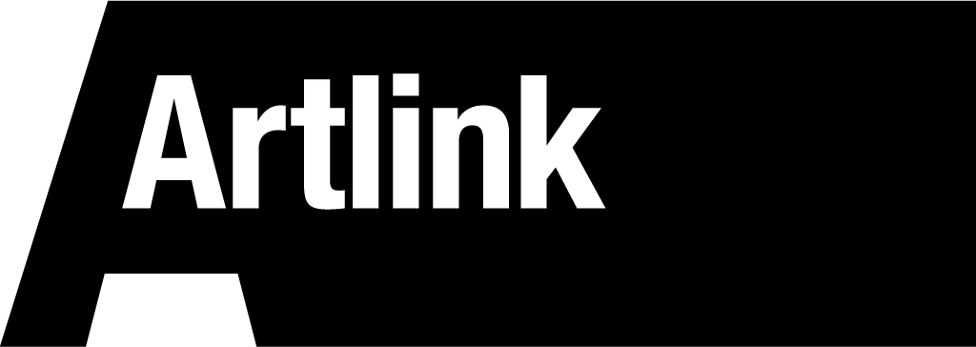
BOARD MEMBER APPLICATION FORM

Instructions: Print clearly in black ink. Answer all questions. Sign and date the form. Artlink encourages applications from disabled people. Please tell us any reasonable adjustments we can make to help you with this application form.

PERSONAL INFORMATION:

First Name ____________________________

Last Name _____________________________

Street Address

__________________________________________________________________________________

Post Code

Phone Number
(____)___________________________________

DETAILS:

Please read the job description and person specification and tell us why you meet the criteria.

__________________________________________________________________________________

__________________________________________________________________________________

__________________________________________________________________________________

__________________________________________________________________________________

How did you hear about this opportunity?

__________________________________________________________________________________

__________________________________________________________________________________

Tell us why you are interested in the work of Artlink.

__________________________________________________________________________________

__________________________________________________________________________________

__________________________________________________________________________________

Is there anything else you would like to add?

__________________________________________________________________________________

__________________________________________________________________________________

Referees:
Please give us the names and contact details of two referees.

Name: __________________________________________________________________________________

Contact: __________________________________________________________________________________

__________________________________________________________________________________

Name: __________________________________________________________________________________

Contact: __________________________________________________________________________________

Please send this form by email to: info@artlinkedinburgh.co.uk or print and post to Artlink, Board Member Application, 13a Spittal Street, Edinburgh, EH3 9DY

This application form can be provided in whatever format is needed.

Deadline: 14th September 2018 at 17:00

